### **Non-Linear Twists: The Curved Soul of Sound**

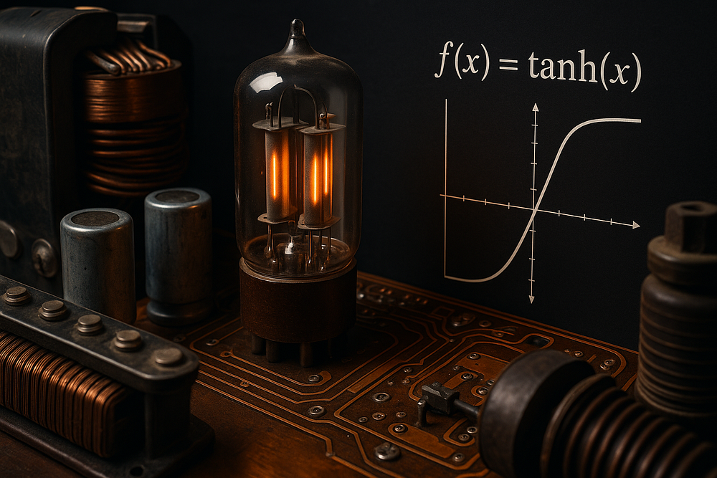

Oooh, the electric guitar’s growl — that fuzzy, harmonic-rich bite that turns a simple riff into a wall of sound. Or think of a modular synth patch where a clean waveform morphs into something gloriously warped, full of unexpected overtones. We’ve all chased that “**warmth**” or “**character**\*\*,” right? Well, here’s the plot twist: it’s often the **non-linearities** in circuits that make the magic happen. Not the pristine, straight-line behaviors we learn in basic electronics, but the quirky, bendy ones where components like diodes, capacitors, and ferromagnetic coils rebel against linearity, introducing **distortion**, **saturation**, and **hysteresis** that breathe life into sounds.

As a synth tinkerer who’s spent countless nights wrestling C++ code for virtual analog models, I’ve come to see non-linearities as the underdog heroes of synthesis. They’re what separate sterile digital tones from those that feel alive, like they’re responding to your touch. Drawing from a stack of research papers — from wave digital filters to capacitor aging quirks — let’s unpack how these non-linear gremlins work, why they matter for synthesis, and how we model them to craft sounds that sparkle with imperfection.

 — -

#### **What Is Non-Linearity? The Math Behind the Sonic Spice**

Ah, the sound of imperfection — that gentle distortion that turns sterility into soul. In the lab, it’s “non-linearity.” In the studio, it’s “warmth.” Let’s unpack the mathematics behind that sonic spice, which fundamentally breaks the rules of ideal **linear systems**.

In linear systems, the principle of superposition holds true:



But the real world — and your favorite amp — doesn’t play by those rules. A non-linear system’s output is not simply proportional to its input.

A simple non-linear function that acts like a soft clipper is the **hyperbolic tangent**:



This function is approximately linear for small input *x*, but it increasingly **saturates** (limits the output) for large *x*.

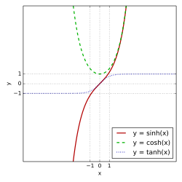sinh, cosh and tanh

*Soft-clipping curve — where math meets mojo.*

Expanding this function as a **Taylor series** shows exactly where the sonic character comes from:



Each higher-order term (like the *x³* and *x⁵* terms) generates new **harmonics** and **overtones** when a sine wave is passed through the function.

**Non-Linear Mechanisms in Analog Circuits**  
In analog circuits, components don’t always play nice. This is what creates the “curved soul of sound.”

Take **diodes** — they conduct current in one direction but resist the other, which creates clipping that adds harmonics. Furthermore they don’t do it ‘perfectly’ — there’s a degree of curent flow oth ways, veying depending upon a number of factors. This behavior is described by the **Shockley Diode Equation**:



It’s exponential — tiny voltage changes yield huge current swings. This is why diode clippers and fuzz pedals roar instead of whisper. This clipping can be simplified in modeling by functions like the **Cubic Soft Clipper**, which is simpler to compute but still deliciously musical:



Another classic is the **Piecewise Hard Clipper**, which makes your sine wave into a square — the definitive transistor “bite”:

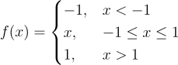

It’s not just overt distortion; subtle non-linearities in ferromagnetic coils and transformers introduce **hysteresis** — a lag where the output doesn’t immediately follow the input. This creates an elusive “**memory**” in sounds. Najnudel et al.’s 2020 work on power-balanced ferromagnetic coil models captures this beautifully, showing how statistical physics explains saturation (when the material can’t magnetize further) and hysteresis, turning a simple inductor into a tone-shaping beast. We’ve all felt that gut punch from a saturated bass synth — it’s non-linearity at play, compressing dynamics and fattening lows.

#### **Taming the Beast: Digital Modeling of Non-Linear Mayhem**

Now, how do we bottle this analog chaos for digital synths? Enter **virtual analog (VA) modeling**, where we simulate circuits down to their non-linear quirks.

A powerful framework for this is **Wave Digital Filters (WDFs)**, which preserve real-world energy flow. They model each circuit element with reflection equations and “adaptors” so the math stays stable. Kurt James Werner’s 2016 dissertation on WDFs is a goldmine here — WDFs let us model non-linear elements like diodes or tubes modularly, preserving energy flow to avoid digital artifacts. Think of it in terms of the pub philosopher’s take on physics: “Keep the power balanced, and the sound stays true.”

Diagram reference: [CCRMA WDF overview](<https://ccrma.stanford.edu/~jos/wdf/>)

**Aliasing & Antiderivative Antialiasing (ADAA)**

But non-linearities love to **alias** in digital land, folding high harmonics back as nasty inharmonics. Non-linearities create harmonics above Nyquist *to* digital chaos.

Enter **antiderivative antialiasing (ADAA)**, a clever fix from Parker et al. (2016), extended by Albertini, Bernardini, and Sarti in their 2020 DAFx paper. ADAA smooths them using calculus:



where *F* is the antiderivative of *f*. This keeps energy consistent while taming fold-back noise, ensuring cleaner distortion pedals or amp sims, even at high oversampling rates.

**Speed and Scale: Real-Time Performance and Component Imperfection**  
Fast-forward to today: simulating non-linear circuits without lag. Ducceschi, Bilbao, and Webb’s 2021 DAFx paper on **non-iterative schemes** for audio circuits is a game-changer. They ditch iterative solvers for linearly implicit methods, solving stiff non-linear ODEs (like diode clippers or ring modulators) explicitly. It’s like upgrading from a bar crawl to a smooth bike ride — faster, stable, and alias-reduced at higher sample rates. For synthesists, this means real-time VA without CPU choke.

Non-linearities aren’t just in tiny components; they scale up. **Guitar cabinets**? Yeh et al.’s 2008 study reveals how cones break up non-linearly at high volumes, adding low-frequency grit that’s “desired” for that classic overdrive snarl. You can model this with static non-linearities post-linear filters. **Transformers** bring their own flavor — Carnhill’s design guide hints at how core materials saturate, introducing hysteresis that warms up signals.

And don’t forget **aging** — components drift over time, adding vintage vibe. Chowdhury’s 2020 “Bad Circuit Modelling” paper nails this, showing how tolerances, temperature, and wear (like capacitor aging from England’s 2012 note) create unit-to-unit variations. Parler’s reliability paper on aluminum electrolytic caps reminds us: non-linear drift over time isn’t a bug — it’s a feature for emulating vintage gear. A synth circuit with “aged” caps might lose highs gradually, mimicking a 30-year-old module.

#### **Non-Linearity as Philosophy**

Every non-linearity bends the rules, just like every artist bends genres. A diode doesn’t apologize for clipping — it *sings* through it.

Non-linearities aren’t flaws; they’re the spark that makes synthesis feel human. From a diode’s clip to a coil’s hysteresis, they add depth, surprise, and that “aha!” warmth. As I’ve tinkered with my own C++-based VA prototypes, I’ve learned: chase perfection, but leave room for the bends. Whether you’re building a modular beast or coding a soft synth, dive into these papers — Albertini et al. for alias-free WDFs, Chowdhury for “bad” models, or Najnudel for thermo-passive coils — and let non-linearities elevate your sounds.

Next time your signal saturates, don’t flinch. You’re not breaking math. You’re just exploring the beautiful edges where linear logic gives way to feeling.

Who knows? Your next patch might just distort in ways that change the game. Keep experimenting, friends — the non-linear path is where the fun lives.

#### **Further Reading & References**

* [DAFx Papers on Non-Linear Audio Circuits](<https://www.dafx.de/>)  
* [Kurt Werner’s Wave Digital Filters Dissertation](<https://ccrma.stanford.edu/>)

**References Roundup: The Non-Linear Edition’s Backbone**

Journal Papers and Key Studies (The Heavy Hitters)  
These unpack the non-linear grit — from alias fixes to aging quirks — step-by-step like a synth build gone gloriously wrong.  
1. Albertini, D., Bernardini, A., & Sarti, A. (2020). Antiderivative antialiasing in nonlinear wave digital filters. Proceedings of the 23rd International Conference on Digital Audio Effects (DAFx-20), 62–69. (ADAA for WDF non-linears; smooths aliases like a code confession gone right — saving your sim from digital screeches.)  
2. Yeh, D. T., Bank, B., & Karjalainen, M. (2008). Nonlinear modeling of a guitar loudspeaker cabinet. Proceedings of the 11th International Conference on Digital Audio Effects (DAFx-08), 1–8. (Cab cone breakups; non-linear warmth for that growl — think of it as the pub philosopher’s take on why old gear sings.)  
3. Najnudel, J., Müller, R., Hélie, T., & Roze, D. (2020). A power-balanced dynamic model of ferromagnetic coils. Proceedings of the 23rd International Conference on Digital Audio Effects (DAFx-20), 203–210. (Hysteresis in coils; stats physics for saturation — freedom-first modeling without overreach.)  
4. Ducceschi, M., Bilbao, S., & Webb, C. J. (2021). Non-iterative schemes for the simulation of nonlinear audio circuits. Proceedings of the 24th International Conference on Digital Audio Effects (DAFx20in21), 25–32. (Fast solvers for stiff non-linears; diode clippers sans iterations — like hacking a ring mod for real-time wins.)  
5. Chowdhury, J. (2020). Bad circuit modelling. Proceedings of an unspecified conference, 1–6. (Likely DAFx or similar based on context.) (Aging and tolerances; “bad” as in beautifully imperfect — relatable for your vintage modular sounds.)  
6. Parler, S. G., Jr. (Year unspecified, circa 2000s). Reliability of CDE aluminum electrolytic capacitors. Internal Cornell Dubilier document, 1–10. (Cap wearout life; electrolytic drift over time.)

**Books, Theses, and Design Guides (The Big-Picture Reads)**  
For when you want the full schematic, not just the patch notes.  
7. Werner, K. J. (2016). Virtual analog modeling of audio circuitry using wave digital filters [Doctoral dissertation, Stanford University]. (WDF bible; non-linear mods modularly — one of my favs.)  
8. Scandalis, P., Smith, J. O., III, & Porcaro, N. (2017). A brief history of physical modeling synthesis, leading up to mobile devices and MPE. Berklee Voltage Presentation, 1–59. (Phys modeling evolution; non-linear transducers to MPE — light jab at overreach in digital perfectionism.)  
9. Carnhill Transformers. (Preliminary Issue). Carnhill Transformers Design Guide, 1–26. (Transformer cores; saturation hacks — empowering underdog innovators with real iron wisdom.)  
10. England, C. (2012). Ceramic capacitor aging made simple. Johanson Dielectrics Inc. Application Note.